Word Reversal Using Stack

ARCHITECTURE DIAGRAM

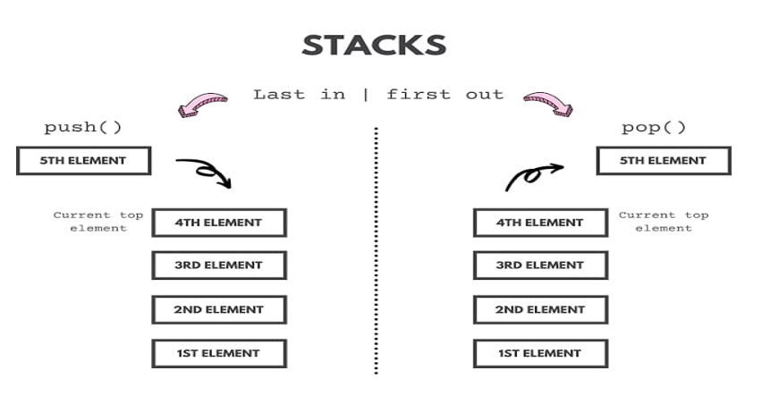

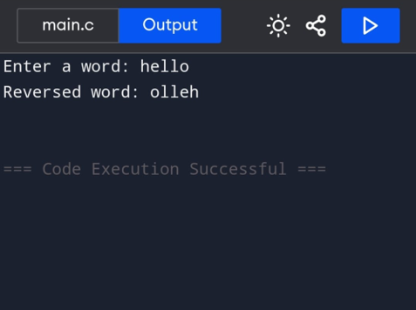
OUTPUT

